Technical Working Group for Seveso Inspections (TWG 2)
TOOL KIT FOR PLENARY MEETINGS
Version 1
Thank you for being willing to host a Plenary Meeting of TWG 2!
The most important thing: Do not make it too complicated!
REMEMBER!
- When reading this tool kit, you will notice that there are always different possibilities to arrange things.
- If you don´t have many resources (time, staff, money), you are well advised to take the easiest way.

TOOL KIT OF TIPS FOR HOSTING A TWG 2 MEETING
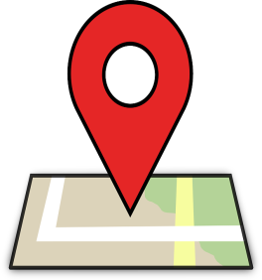
If you host a plenary meeting in your country, you should take care about the following things:
- MEETING PLACE
A town or city that is well connected by public transport to an international airport. People do not mind travelling at least for a 1-2 hour train ride or bus trip to a nice place.
You don´t need to make it complicated!
Easy:
Town, where your office is located. You have enough staff and organisation to help you.

Difficult:
Nice places are very often not well connected to public transport. Think about how you can get the people to this place and if you need extra money for this.

Remember also that, if the location is not near your workplace, you will need extra hotel costs for yourself and colleagues.

- MEETING VENUE
Requirements:
- One big meeting room (ca. 25 Persons)
- Two or three additional little meeting rooms for break out groups (ca. 8 persons)

Easy:
This could be in your office (easiest way and cheapest)

More difficult:
A hotel meeting place
- Talk to the hotel of the participants: Do they have a meeting room? Can you get a special (low cost) arrangement for the meeting room? On nightly room rates for each guest?
- Sometimes the hotel will offer meeting rooms for free if you guarantee a certain number of guests. Remember, however, that you need a few small meeting rooms (for at least one day) in addition to one big meeting room.

Depending on the need, you may have to talk to your ministry and ask for financial resources
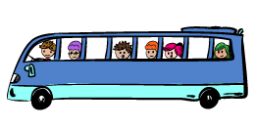
- TRANSPORTATION
You have to make sure that your participants can arrive at the hotel and the meeting place and can get back home!

Easy
Public transport and walking are always the easiest option.
- Confirm whether or not participants can easily take public transport to and from the airport, and if the times and locations are convenient.
- Confirm whether or not participants can easily take public transportation, or walk, from their hotel to the meeting place.

More difficult
If there is no public transport to the meeting location from the airport, you may need to arrange a bus or shuttle to take people to and from the airport.
- Example 1: The government arranges and pays for shuttles (buses or taxis) to and from the airport. This has happened for a few events.
- Example 2: The government arranges the shuttles, but the participant pays. For one recent event, the government asked a private transport company to meet people at the airport and take them back to the airport after the meeting. It cost ~16 Euros roundtrip per participant.
If you are arranging a shuttle, you will need to ask everyone to give you their flight times!

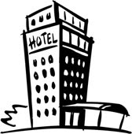
- HOTEL
You have to find a hotel (or hotels) for the participants.
The meeting venue should be accessible from the hotel by public transport or walking.
You should make a special arrangement with at least one hotel for a block of rooms. This is important because:
1) You need to make sure that enough hotel rooms are available for your participants near the meeting location. You do not want that many participants have trouble finding a hotel.
2) It makes the social part of the meeting go smoothly when participants can be together in the same hotel, or in hotels that are near each other. It is good for the meeting for participants to have a chance to meet each other at breakfast and/or dinner.
It is nice to have the hotel close to the meeting venue. It helps to have the option to choose between an expensive and a cheap hotel. The hotels don´t need to be luxurious (a clean and charming- 3-star works fine).
As noted above, you could try to make an arrangement with the hotel. If people rent rooms there, the hotel may give you a meeting room without any extra costs.
In some cities, the hotels with meeting rooms are more expensive. You should make sure you find a place that is within government allowances for accommodation (e.g., compare it with what your own government allowance would be).
Easy:
Just look for one hotel and make a special arrangement for a block of rooms with that hotel.

More difficult:
Make an arrangement with more than one hotel, including a low cost hotel. It is not so important to make an arrangement with a low cost hotel because people or their organizations can easily do this themselves. However, if there are very few low cost hotels in the area, it helps if you can make a special low-cost arrangement for these participants.

- LUNCHES/DINNERS
You don´t need to pay for lunches or dinners. We all can pay for our food ourselves.
You should have a recommendation for a nice restaurant for the evenings, where people can meet if they want. Ask in the meeting, who wants to join for dinner and give the current number of persons to the restaurant for the reservation.
This is important especially on the first evening. It helps the participants become familiar with each other.
- PRACTICAL INFORMATION
In advance of the meeting you should send the practical information on transport and hotel accommodations to all participants.
It should contain:
- The transport arrangements or the connection to and from the public transport from international airport train/bus connection (also, where applicable, a link to airport taxi information, as an option)
  - to the hotel
  - to the meeting place (if different)
- The name and address of the meeting place
- The name, website and e-mail address of the hotel and price of rooms
- A local map showing how to get from the meeting place to the hotel (if they are different)
- Other information as you think necessary, e.g.,:
  - Identification needed to enter the meeting venue
  - Currency exchange with the Euro
  - Information on special attire for events (e.g., boat ride)
  - Questions about dietary preferences (for pre-planned menus)
If you are a super hero, you also have a description of public transport (price, how it works, where you can find the ticket machines).
But: You don´t need to be a super hero!

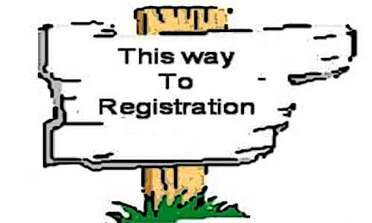
- REGISTRATION AND KEEPING TRACK OF PARTICIPANTS
The EC-JRC (MAHB) will manage registration for you.
It is important to have a registration form and to track the hotel reservations so you know:
- Who is coming (no surprises)
- Checking that participants have made hotel reservations
Be in copy of the hotel reservations.
Ask for arrival and departure times of the participants.
Provide a list for the registration desk at the meeting venue.
In the attachment, you´ll find some examples for the mentioned points above.

Annex 1: Practical Information Document from TWG 2 Meeting 2018 in The Hague, the Netherlands
PRACTICAL INFORMATION
The annual meeting of the TWG 2 will be held in The Hague, The Netherlands from 26 – 28 September 2018.

The venue is the Ministry of Social Affairs and Employment (and The Ministry of Health, Welfare and Sport – See map on page 4)

Address: Parnassusplein 5, 2595 The Hague

This is next to the train-, tram- and busstation: Central Station

All participants are invited on Wednesday 26 September for a lunch from 12.30, before the meeting begins at 14:00. The meeting ends on Friday 28 September around noon, followed by lunch.

If there are other questions regarding the venue, accommodation, and transport or just on staying in The Hague after reading this, please let me.
Also please let me know your flight or train arrival and at which hotel you will be staying at swiers@minszw.nl.

Accommodation

There are many hotels in The Hague and September is a quite busy time in The Hague so the hotels are expensive in the citycentre. There are 2 hotels which are close by the venue where we have made a reservation for the TWG. We have a reduced rate, but do check since other organizations do have good financial arrangements with the Accor hotel group.
You can make a reservation by sending an email to the hotel. In this email, please mention your name and the check-in and checkout date.
They will sent a confirmation afterwards and ask for credit card conformation.
Do make the reservation under TWG in the heading of the email.

The following hotels guarantee available rooms until 11 September.

Mercure Den Haag Central
http://www.accorhotels.com/nl/hotel-1317-mercure-hotel-den-haag-central/index.shtml
Single use: € 135,00 per room per night including breakfast, excluding citytax (€3.40)
Double use: € 150,00 per room per night including breakfast, excluding citytax (€3.40)

Email: h1317-re@accor.com

From the Ministry of Social Affairs and Employment (Parnasusplein 5 – Castalia) to the Hotel Mercure
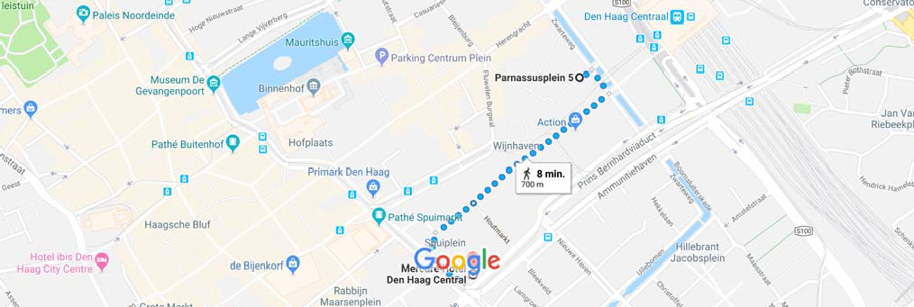

Novotel Den Haag City Centre –
http://www.accorhotels.com/nl/hotel-1180-novotel-den-haag-city-centre/index.shtml
Single use: € 139,00 per room per night including breakfast, excluding citytax (€3.40)
Double use: € 154,00 per room per night including breakfast, excluding citytax (€3.40)

Email: h1180-re@accor.com

From the Ministry of Social Affairs and Employment (Parnasusplein 5 – Castalia) to the Hotel Novotel den Haag City Center
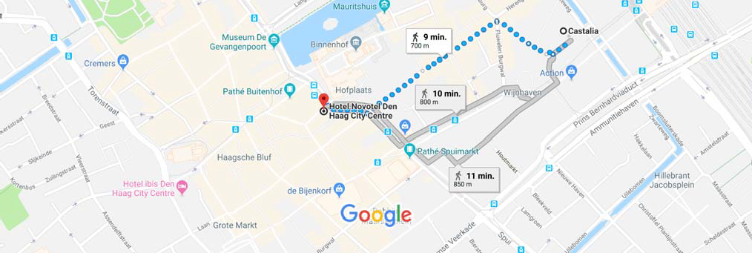

Transportation

By Air or train
From Schiphol Airport, take the train to Den Haag Central Station. Get off at the end station Den Haag Centraal and the venue will be just a four-minute walk away.

From Rotterdam/The Hague Airport, you can take bus 50 towards Rotterdam. Get off at Meijersplein Station and switch onto the E tram towards The Hague. Get off at the end station Den Haag Centraal and the venue will be just a four-minute walk away.

Take the train to The Hague Central Station from Rotterdam Central Station or Utrecht Central Station if you arrive from Germany or Belgium or France.

By Road
For GPS navigation, please enter Parnasusplain 5. The Ministry does not have an own parking places. There is a Q-Park parking garage under the building.

A4 Amsterdam - The Hague:
Head south on the A4 towards Den Haag.
Take exit 8-Leidschendam onto the E30/A12 towards Den Haag/Zoetermeer/Utrecht
Merge onto the A12 and continue for 3.1 km.
Take exit 2 Den Haag centrum. At the end of the exit go left on the Prins Bernhard viaduct. Before the First traffic light go to the left lane so you can make a u-turn at the traffic light. Do not take the same route back on the viaduct, but go on the small road and follow the sign Helicon. Take a left under the Bernhard viaduct onto the Oranje Buitensingel. Cross the bridge on the second possibility and go strophe left again. The entrance of the parking garage Helicon is there just before the tram viaduct.

A12 Utrecht - The Hague:
Uit de richting Utrecht
Take the A12 from Utrecht untill the Prins Clausplein. Keep going in the direction Den Haag centrum. Take exit 2 Den Haag centrum. At the end of the exit go left on the Prins Bernhard viaduct. Before the First traffic light go to the left lane so you can make a u-turn at the traffic light. Do not take the same route back on the viaduct, but go on the small road and follow the sign Helicon. Take a left under the Bernhard viaduct onto the Oranje Buitensingel. Cross the bridge on the second possibility and go straight left again. The entrance of the parking garage Helicon is there just before the tram viaduct.

A13 Rotterdam - The Hague:
Head north on the A13 and then take the exit onto E30 towards Den Haag/Utrecht
After 3.1 km on the E30, follow the signs to Voorburg/Den Haag/A12 and merge onto the A12.
Take exit 2 Den Haag centrum. At the end of the exit go left on the Prins Bernhard viaduct. Before the First traffic light go to the left lane so you can make a u-turn at the traffic light. Do not take the same route back on the viaduct, but go on the small road and follow the sign Helicon. Take a left under the Bernhard viaduct onto the Oranje Buitensingel. Cross the bridge on the second possibility and go straight left again. The entrance of the parking garage Helicon is there just before the tram viaduct.

Annex 2: Example of Practical Information from TWG 2 Meeting 20
Practical Information on Annual TWG2 meeting
4 – 6 June 2014
University of Warwick, Coventry, UK

Dear TWG 2 members

The annual meeting of TWG 2 will be held in Coventry, United Kingdom at Scarman Training and Conference Centre, University of Warwick, Gibbet Hill Road, Coventry, CV4 7AL, United Kingdom.

The meeting will take place from 14:00 on 4 June and finish on 6 June at around noon. Lunch will be provided before the start of the meeting on 4 June and after the meeting on 6 June. A preliminary agenda is attached.

Accommodation

A pre-reservation for 25 single rooms exists at the Scarman Training and Conference Centre from 4 – 6 June. Please make your reservation by contacting Tracey Abrahart by Tuesday 6 May. The rate agreed with Scarman is £107.25 (GBP) for 4 June and £80 (GBP) for 5 June. This rate includes breakfast but excludes VAT.

For reservations, please contact

Tracey Abrahart
European Process Safety Centre
Tabrahart-epsc@icheme.org
Tel: +44 1788 534409

Transportation

By Road
Situated at the hub of the national motorway network, all major links (M1, M6, M40, M42, M45 and M69) are within easy reach.

By Air
Birmingham International Airport is approximately 30 minutes by taxi (approx. 13 miles). A frequent train service runs to Coventry from Birmingham International station, adjacent to the airport. We are also located approximately 1 hour from Nottingham East Midlands Airport, 2 hours from Luton Airport and 15 minutes from Coventry Airport.

By Rail
Coventry Intercity station is the nearest station and only four miles from the University. The Euston service runs half-hourly with an approximate journey time of 70 minutes. Services to Birmingham International and Birmingham New Street are frequent throughout the day. There is a large taxi rank at Coventry station.
Location
Scarman Training and Conference Centre
University of Warwick,
Gibbet Hill Road,
Coventry, CV4 7AL, United Kingdom.
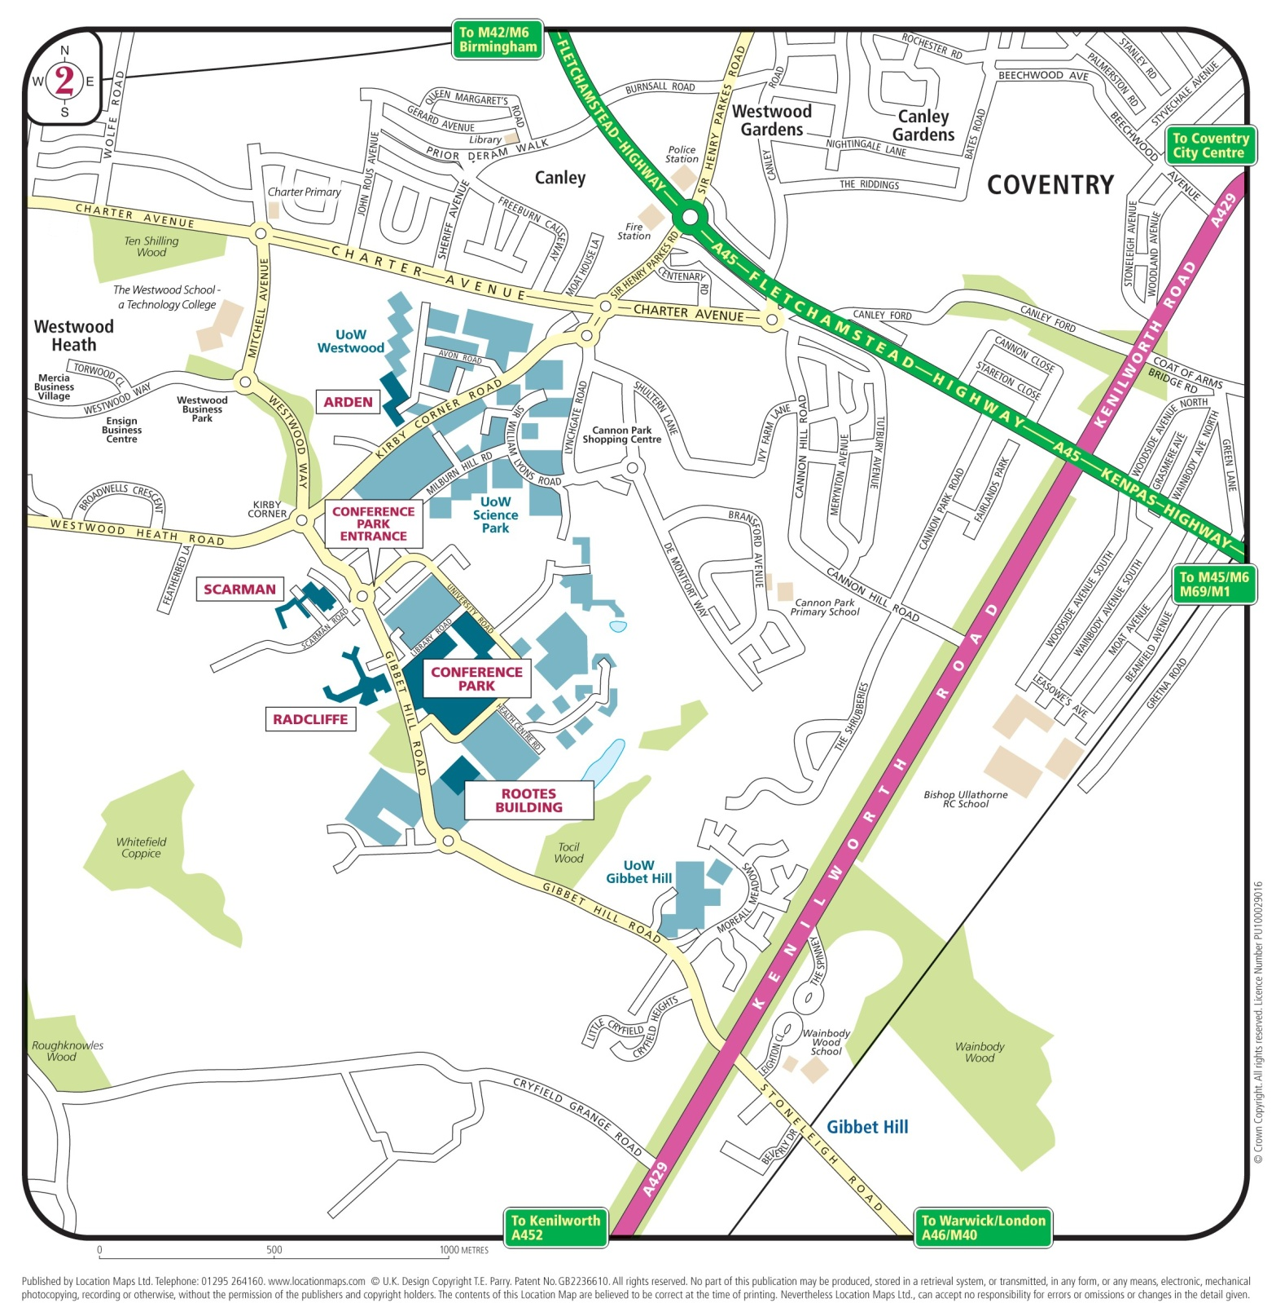

ANNEX 3: Example of Practical Information from MJV Cyprus 2017

Mutual Joint Visit Workshop for Seveso Inspectors
on Liquefied Petroleum Gas (LPG) and Liquefied Natural Gas (LNG) Sites

Organised by the Cyprus Ministry of Labour, Welfare and Social Insurance
and the European Commission Joint Research Centre

Hotel Cleopatra, 26th - 28th September 2017, Nicosia, Cyprus

Practical Information Guide

REGISTRATION
Registration is now open and will remain open until the 4th of September 2017. You are kindly requested to complete the registration online at https://web.jrc.ec.europa.eu/rem/app.html?#/subscription-form-screen/meetingId=84150.

- MJV WORKSHOP VENUE

The workshop will take place at the Hotel Cleopatra (https://www.cleopatra.com.cy/cleopatra/ ) in the city centre of Nicosia.

- ACCOMMODATION
We have reserved a block of 40 rooms at the Hotel Cleopatra. The room rate is Single Room B/B €69.00, Double Room B/B €89.00

Each participant must arrange his own accommodation. To get the above special rates you must complete the attached hotel booking form.

- TRANSPORT FROM/TO AIRPORT
To reach Nicosia, you can use the shuttle bus service or a taxi. Shuttle bus services run to and from:
  - Larnaka International Airport and Nicosia (http://www.kapnosairportshuttle.com); and

Shuttle Service
- 1 to 3 persons
From Larnaca Airport to Nicosia shuttle station and then to Hotel Cleopatra
Cost 16,00 per person

- For 4 or more persons
From Larnaca Airport to Nicosia shuttle station and then to Hotel Cleopatra
Cost €8,00 per person

- 1 to 3 persons
From Hotel Cleopatra to Nicosia shuttle station and then to Larnaca airport
Cost €16,00 per person

- For 4+ persons
From Hotel Cleopatra to Nicosia shuttle station and then to Larnaca airport
Cost €8,00 per person

- From Larnaca Airport to Nicosia shuttle station: Cost €8,00 per person

- From Nicosia shuttle station to Hotel Cleopatra: Cost for 1 to 3 persons: €8,00 per person
for more than 3 persons: free

- From Hotel Cleopatra to Nicosia shuttle station: Cost for 1 to 2 persons: €8,00 per person
for more than 2 persons: free

- From Nicosia shuttle station to Larnaca Airport: Cost €8,00 per person

Taxis
Prices for taxis range depending on destination. Indicatively these are:

Larnaka - Lefkosia | €50
Larnaka - Limassol | €60
Larnaka - Protaras - Ayia Napa | €60
Paphos - Limassol | €60

- DINNER/EXCURSION
You are kindly invited to a dinner at on the 26th of September at Mezostrati Cyprus Tavern in Nicosia and at Zanettos Cyprus Tavern in Nicosia on the 27th of September. In case you wish to participate, please indicate this at the relevant section of the on-line registration system for the MJV Cyprus.

- CONTACT PERSONS

Programme and Practical Information
Maureen Wood
European Commission Joint Research Centre
maureen.wood@ec.europa.eu
T: +39 0332 78 9140 (office)

EC Travel reimbursements
Orsolya Sudar
European Commission Joint Research Centre
Email: JRC-E2@ec.europa.eu

- GENERAL INFORMATION ABOUT CYPRUS

Languages
Greek and Turkish are the official languages of the Republic of Cyprus. English is widely spoken.

Local Time
Cyprus Time is GMT +2.

Climate & Weather
The island's climate is characterised by hot summers and mild winters. By June, summer will have arrived in Cyprus. Temperatures continue to rise and reach their highest in July and August during which the average maximum temperatures range between 27°C and 36°C. However, in the warmest days of the summer you should expect higher temperatures during midday, especially inland (Lefkosia), where it might soar towards 40°C. From September, the temperature gradually drops yet it remains rather hot. October is still warm enough and sunny and the sea water is still comfortable for swimming. The evenings in June, especially in the beginning of the month and from the end of September could be a little chilly.
In June and September rain is considered rather unusual and in July and August it would be a surprise especially at night.
In the mountains it is pleasantly cooler during the day and, as expected, it is colder at night.
In December the mean daily maximum temperature inland is 8°C and the mean daily minimum is 7°C. In September the maximum temperature inland is 33°C and the daily minimum is 8°C.

What to wear in the summer
Recommended clothes are light weight summer clothing and long sleeve linen top or shirt for evenings. It is always a wise idea to use sun protection, such as hats, sunscreen and sunglasses.

Currency
The currency of Cyprus is the Euro.

Currency Exchange
All banks operating in Cyprus offer foreign currency exchange services and quote the exchange rates of the Euro against all major foreign currencies daily. Foreign currency can also be exchanged at hotels.

ATMs and Credit Cards
All major banks in Cyprus have automatic teller machines (ATMs) in most towns and in the majority of the large villages. All major credit cards are accepted almost everywhere.

Electricity supply
The electricity supply in Cyprus is 230 volts, a.c. 50 Hz. Sockets are usually 13 amp, with 3-point plugs, square pin. Many hotels provide adaptors upon request from the reception.

Smoking
Smoking is prohibited in all indoor public places and night clubs.

Opening hours
Shops normally open around 09:00 and close around 19:00 except Wednesday afternoon (up to 15:00 hrs). During the summer period June 15th - August 31st there is an optional three hour afternoon break from 14:00 - 17:00. Shops in tourist areas, large shopping centres and department stores may stay open on weekends and public holidays as well.

Banks are open on workdays (Monday to Friday) usually between 08.30 and 13.30. From October to April they are also open on Monday afternoon between 15.15 and 16.45 . Banks are closed on weekends and publjc holidays. Some banks in central tourist areas are open in the afternoon specifically to provide services to tourists.

Restaurants and cafes have varying opening hours, but lunch is most often served between 12:00 and 15:00. Dinner is served from 19:00 until late in the evening.

Driving Side
Driving is on the left-hand side of the road. All the international road traffic signs are in use and placed on the left-hand side of roads and highways . On roundabouts, priority is given to the right side.

Emergency Number
Call 112, the EU-wide emergency number for police, fire department and ambulance .

Dial Code for Cyprus: +357

Telephone Directory Assistance: 11892, 11822, 11800, 11833, 11811
Site of national carrier for direct flights from main cities: http://cyprusair.com

Annex 3: Practical information from TWG 2 Meeting 2016

TWG2 plenary meeting, 11-13 May 2016, Brussels

Practical information

The venue

Address
The meeting will take place in the main office building of the Belgian Federal Public Service Employment, Labour and Social Dialogue.
The address is: Rue Ernst Blerot 1, 1070 Bruxelles (in French) or Ernest Blerotstraat 1, 1070 Brussel (in Dutch).

Accessibility by public transport
The venue is next to the railway station ‘Bruxelles-Midi’ (French) - ‘Brussel-Zuid’ “(Dutch). This is also the arrival station of Eurostar, Thalys, TGV, ICE and InterCity.

At basement level of the railway station is located the subway station “Gare du midi” (French) – “Zuidstation”, which is a stop of the:
- Underground tram (T) lines 3 and 4 (quick north-south line through the city centre).
- Metro (M) lines 2 and 6

Access from the railway/underground station
In the station you take the exit Place Victor Horta (or Victor Hortaplein). You will see a large yellowish building in front of you, parallel to the building housing the station. Go to the right end of the building (round shaped). That’s the entrance.

See also on the google maps screen shot below.

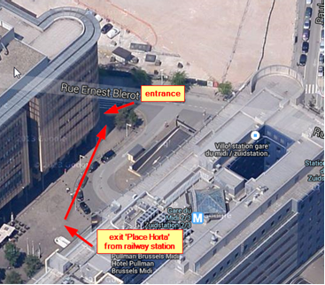

Hotels
Participants are kindly requested to arrange their own accommodation arrangements. No pre-booking has been done.
Some practical recommendations are given below to ensure an easy access to the venue. Please do not hesitate to contact us if you need any assistance in choosing your accommodation.

Brussels city centre
The hotels Ibis and Novotel at the ‘Place Sainte-Catherine’ are often used by our European colleagues.
These hotels are located in one of the nicer areas of Brussels (which is convenient if you want to go out at night). Transport from these hotels to the venue is easy by public transport. The underground tram lines 3 (direction “Churchill”) and 4 (direction “Stalle”), which can be taken at the underground stations De Brouckère or La Bourse, take you directly to Gare de midi in about 10 minutes.
The hotels, the tram line and underground stations De Brouckère and La Bourse are indicated on the map below.
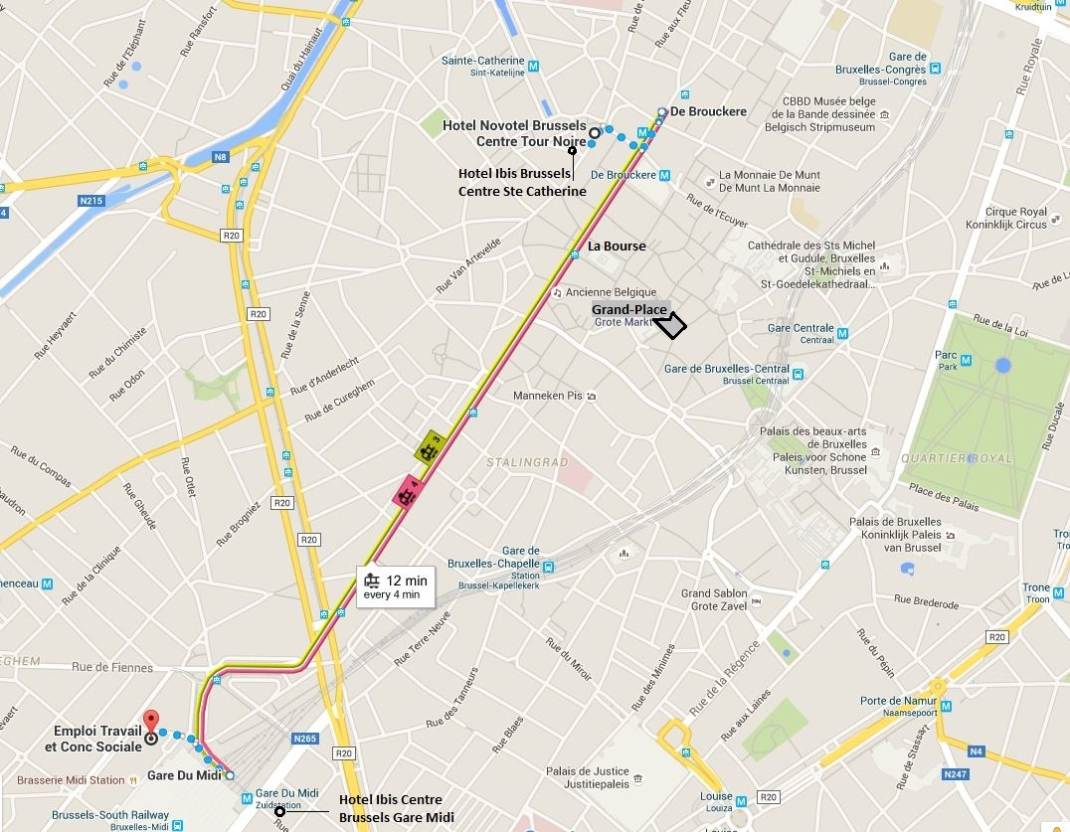

Other areas
For hotels in another area, please make sure you are close to a metro station (see public transport in Brussels).
There are also some hotels close to the venue in the Bruxelles-midi area, but this area is less interesting for spending the evening in town.

Public transport in Brussels
The quickest way of travelling in Brussels is by the underground M lines (1-2-5-6) and T lines 3-4.
These lines can be selected on the interactive map of the Brussels public transport company and gives you a good oversight of the different connection possibilities: http://www.stib-mivb.be/irj/go/km/docs/resource/Plan_tiny/index-en.html.
Information on tickets and fares in English can be found at: http://www.stib-mivb.be/tourist.html?l=en.
A one way paper ticket for all lines (metro, tram and bus) costs 2.10 euro and allows 1h of travel in the Brussels district. These tickets have to be bought at the vending machines.
Multiple trip tickets (5 or 10 trips) can only be charged on a Mobib Basic Card, which costs 5 euro’s and is rechargeable (interesting if you come on a regular basis to Brussels).

Airport – Brussels city centre

From/to Brussels National Airport (BRU)

By public transport

The airport train station is located below the terminal (basement level-1). Up to 6 trains an hour connect the airport to Brussels North (13min), Brussels Central (17 min) and Brussels Midi (23 min) stations. Fare for a one way ticket, 2nd class, is around € 8.60.

More information can be found at:

Website Brussels airport: http://www.brusselsairport.be/en/passngr/to_from_brussels_airport/train/

Website Belgian Railway Company: http://www.belgianrail.be/en/Default.aspx
(timetable and on line ticket buy, choose from “Brussels Airport” to “Bruxelles-Midi / Brussel-Zuid”).

For hotels at the Grande-Place: by foot from railway station Bruxelles-Centrale

For hotels at De Brouckère – La Bourse (such as the hotels Ibis and Novotel at the place Sainte-Catherine):
- In the railway station “Bruxelles-Nord” take underground line tram 3 or 4 direction “Gare de midi”, 2nd stop De Brouckère or 3th stop La Bourse
Or
- In the railway station “Bruxelles-Centrale”, take metro line 1 (direction Gare de l’Ouest) or 5 (direction Erasmus), 1st stop De Brouckère or 2nd stop Sainte-Catherine.

By taxi
Taxis with a taximeter are permanently available in front of the arrivals hall. The fare from the airport to the city centre of Brussels is normally around € 45.

From/to Brussels South Charleroi Airport
Since Brussels Charleroi is about 55 kilometres from Brussels, it is not the closest airport to Brussels.
The most used and convenient method to travel from Brussels Charleroi Airport to Brussels is by shuttle bus. For fares, timetable and booking: http://www.charleroi-airport.com/en/acces/shuttle-buses/index.html.

Registration

If you’ll be attending the TWG2 meeting, please send the registration form an e-mail to Peter Vansina (peter.vansina@werk.belgie.be) with Maureen Wood (Maureen.wood@jrc.ec.europa.eu) in copy by NO LATER THAN 22 APRIL 2016.

Page 5 of 5

