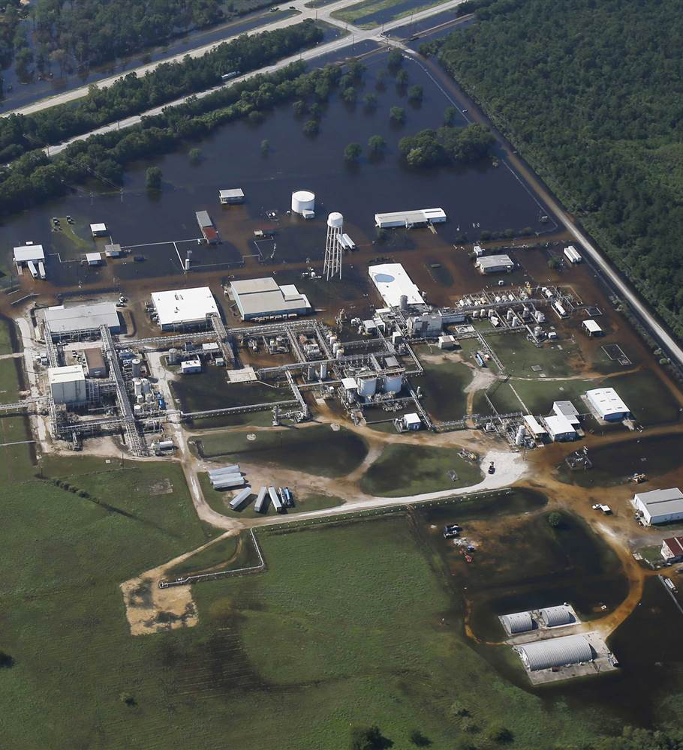

DGPR
SRT
SDRA
BRIEC

Nov 2017

Natech - Inondations

Action nationale 2018

RAPPORT
SUMMARY
1 - National flood action 2018 3
1.1 - Feedback 3
1.2 - Census carried out during the summer of 2017 4
1.3 - Implementation of national action 5
2 - Types of flood hazards 7
2.1 - Overflow of watercourses 7
2.2 - Marine submergence 7
2.3 - Runoff 8
2.4 - General information on the hazard 9
2.5 - Keep informed about the hazard 10
3 - Preparing for the inspection visit 12
4 - Sequels 13
5 - Additional questions that may be asked 14
5.1 - Knowledge of the hazard (part 1 inspection grid) 14
5.2 - Identification of issues (part 3 inspection grid) 14
5.3 - Consequences on the environment and third parties (part 5 inspection grid) 16
6 - Inspection grid 19
7 - Grid for DDT(M) 20
8 - Model balance sheet 21

Flood Action 2018

The objective of this action is to carry out a national inventory of Seveso establishments in flood-prone areas, in order to be able to decide on the next steps concerning the protection of these establishments against the risk of flooding.

Feedback
The ARIA database lists between 1992 and 2016, 823 French events originating from a natural event (flood, lightning, intense heat or cold). The trend of the latter is upwards as shown in the graph below. Concerning the episodes of floods or intense precipitations, these are observed in 277 events. They are thus well ahead of the natural phenomena impacting industrial installations.
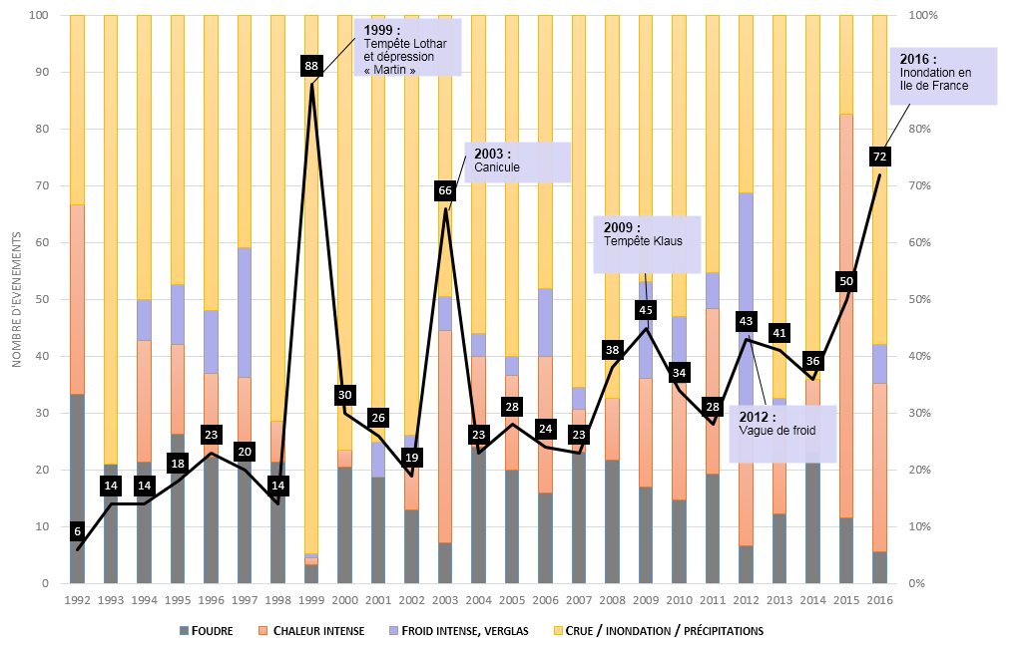
All sectors of industrial and agricultural activity are exposed to natural risks and in particular flooding: chemicals, refining, agri-food, transport pipelines, underground gas storage, etc. The majority of scenarios observed relate to flooding of rivers or in the accumulation of rainwater as a result of its runoff.
Consecutive to soil leaching, the discharge of hazardous or polluting materials constitutes the most predominant dangerous phenomenon in the event of a factory submersion. Fires have also started due to insufficient control of electrical installations after a flood, which generally increases the risk of short-circuits.
Regarding the consequences of the events, they are essentially economic due to the extensive water damage. However, damage to the environment through water or soil pollution was observed in 42 events.
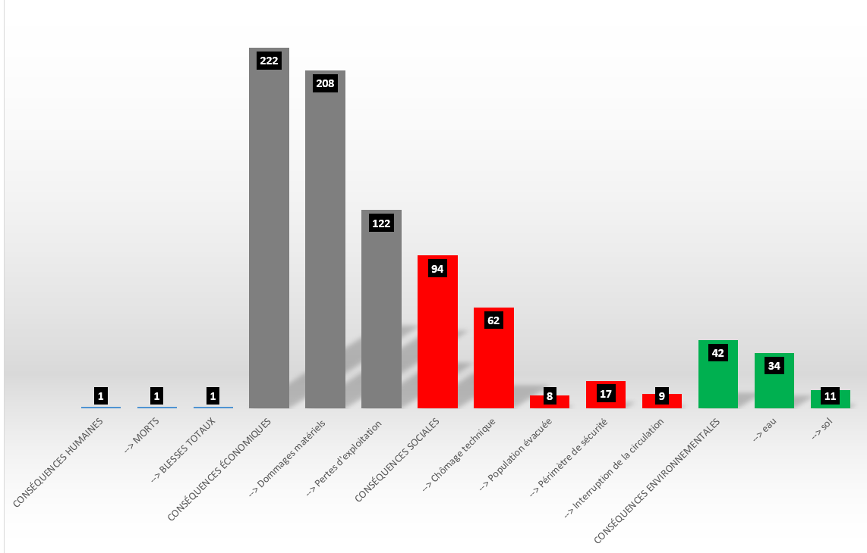
Breakdown of the consequences of the 277 events listed in ARIA

Census carried out during the summer of 2017
In France, we have various databases concerning the risk of flooding. We find the following bases:
- EAIP maps (approximate envelope of potential floods);
- maps on the TRI (territory at risk of flooding;
- the PPRi (flood risk prevention plan);
- the AZI (Atlas of Historical Flood Data);
- the BDHI (historic flood database);

All the regions of the DREAL/DEAL/DRIEE carried out during the summer of 2017 an identification of the Seveso sites (upper and lower) impacted by the risk of flooding. The identification of these sites was carried out heterogeneously from one region to another. Indeed, some regions have been able to identify all the industrial sites affected by the flood risk from all the existing databases and other regions only by relying on some of them. It is thus highlighted that at least 352 Seveso establishments are likely to be impacted by the flood risk.
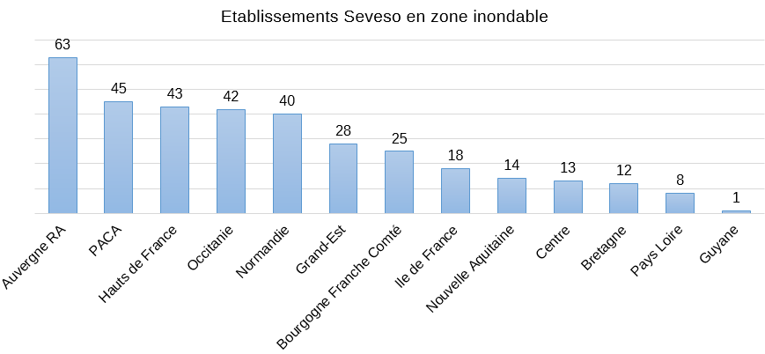

Implementation of national action
For at least half of the high threshold Seveso installations and at least a third of the low threshold Seveso installations identified as being in a flood zone (based on a hundred-year marine flood or submersion), you will examine the measures taken to avoid occurrence of a major technological accident in the event of flooding. The relevance of these measures must be assessed according to their degree of planning, realism if they require human intervention (notice period, possibility of access to the premises, etc.), and effective availability in a degraded situation (location of the ordered…). The ability to handle the situation in the event of a larger flood will be assessed. A national doctrine will be developed in the light of this control campaign; Discussions may take place on the relevance of issuing additional orders in the most sensitive cases.

Selection
It is advisable to retain the industrial sites which are concerned by the flood risk for a hundred-year flood or marine submersion.
We will therefore not retain the sites when the cartography is that of an event rarer than a hundred years, or when a doubt about the return period remains.

- The TRIs and PPRIs (approved or in the process of being drawn up) include maps of centennial events: all the establishments in the corresponding zoning must be identified, in order to carry out the visit of at least half of the SSHs and one third of the SSBs.
- The other databases may require more extensive investigations, with more random knowledge of the return period (EAIP, AZI, BDHI, etc.): if the census work and knowledge of the return period can be carried out by February 2018, the corresponding establishments will be included in the action. Otherwise, it is desirable to carry out the census during the year 2018, without carrying out any inspection.

Input in S3IC
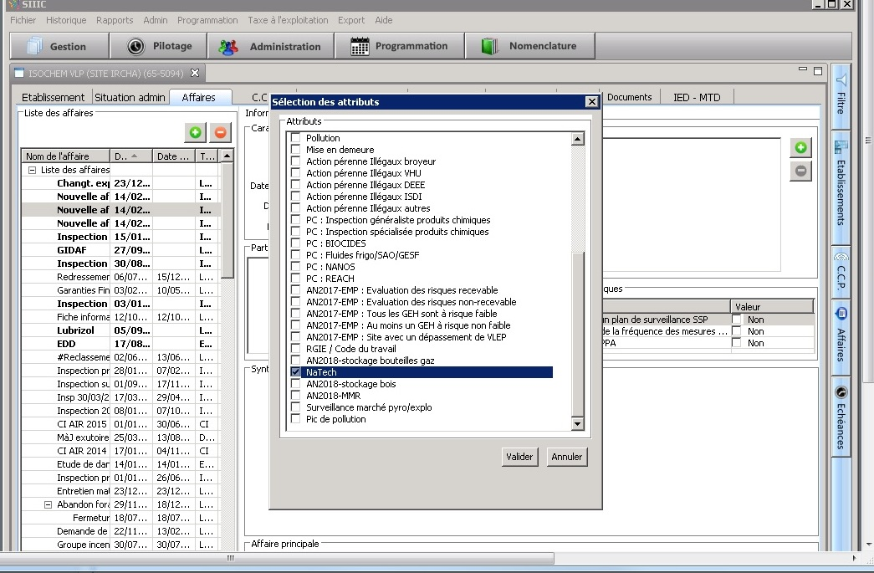
Once the visits have been carried out, you are asked to fill in the S3IC database in which a "Natech" indicator has been introduced:

Types of flood hazards

Overflow of streams
Two types of overflows can be distinguished:
- Overflow by slow flood : overflow linked to river floods, it is characterized by a slow rise in water (from several hours to several days), which can generate lasting floods (from several days to several months). These floods most often occur in large plain basins (thousands or tens of thousands of km²), with little relief and few slopes. They are the result of successive episodes of widespread rains and are therefore more easily predictable, although they are likely to generate extremely significant damage.
- Overflow by rapid flood : overflow corresponding to very rapid rises in rivers (from a few tens of minutes to a few hours). They generally take place on watersheds of modest size (a few tens to a few thousand km²) but experiencing a marked relief (mountains, deep valleys, sectors with steep slopes, etc.) They are often caused by episodes of fairly short rain. duration, but of high intensity (several tens of mm/hour).

Characterization :
When the site is affected by a watercourse overflow hazard, it is necessary to collect various information that will make it possible to characterize the type of hazard to which the site may be subject. The following relevant information will mainly be retained:
- The height of the waters;
- The speed of the waters;
- The kinetics of the phenomenon (speed of ascent, descent);
- If applicable, the probability of a protective structure failure.

marine submersion
The marine submersion hazard is defined as the temporary flooding by the sea of coastal areas, under adverse meteorological and oceanic conditions such as low atmospheric pressure linked to a storm, swell, strong winds or strong tidal coefficients in conjunction with high seas.
There are different modes of marine submersion:
- Submersion by overflow , when the sea level is higher than the crest level of the structures or the natural terrain;
- Submersion by overtopping of sea swells linked to the waves, when after breaking of the swell, the sea swells exceed the crest level of structures or natural terrain; in estuaries, this phenomenon can be combined with the flooding of the river, we then speak of fluvio-maritime flooding;
- Submersion by rupture of the protection system.

Characterization :
When the site is affected by the marine submersion hazard, various information should be collected concerning the following characteristics:
- The water height;
- The speed of water flow;
- The speed of rising waters;
- If applicable, the probability of a protective structure failure.

runoff
Runoff is the circulation of water that occurs on slopes outside the hydrographic network during a rainfall event. Its concentration causes a rapid rise in river flows, which can be amplified by the contribution of groundwater. There are different types of runoff:
- Diffuse runoff whose thickness is low and whose streams of water stumble and divide on the slightest obstacle;
- Concentrated runoff organized in parallel rills or gullies along the steepest slope. It begins to erode and can temporarily mark its mark on the slope;
- Sheet runoff , which is quite common on low slopes, covers the entire surface of the slope. Runoff is all the more important as the land is more impermeable, the vegetation cover weaker, the slope steeper and the precipitation more violent. But it remains a natural phenomenon that cannot be prevented. Unfortunately, human intervention is sometimes a source of aggravation of this phenomenon.
Runoff is a phenomenon of rainwater flowing over a catchment area, in a diffuse or concentrated way, which continues until it encounters a hydrographic element (river, marsh, etc.), a drainage network or a low point where it will accumulate.
The runoff phenomenon can be due to natural or anthropogenic elements. It can also be directly responsible for flooding in a territory far from any watercourse, such as contributing to the formation of floods in permanent or intermittent watercourses (talweg or water collection line). The two types of flooding can also be combined during the same event.
The flood resulting from the runoff phenomenon has the following characteristics:
- Often geographically localized (catchment area of about ten km²);
- Rapid and sudden: the time for the water to rise can vary from a few tens of minutes to a few hours and can be out of step with the rainfall event, depending in particular on the degree of soil saturation or the obstacles encountered by the water on the his journey ;
- Occurring sometimes far from any watercourse, ie where a flood is not generally expected;
- Sometimes violent, with an energy of the waves which often causes a lot of material damage, as well as soil erosion, which means that it is sometimes accompanied by mudslides.

Origin of the phenomenon
Since runoff is caused by rainfall, it depends mainly on its intensity, duration, accumulation, extent and frequency, as well as the topography and nature of the watersheds.
Depending on local conditions, runoff flooding usually follows:
- Either a rain, possibly brief, but of very high intensity (more than 50 mm/h). In this case, the water flows arriving at the ground are greater than the capacity for infiltration or entry into the sewerage network and, not all of the water can be taken in charge, part of it runs off the surface. This type of runoff is rather preponderant in basins with compact, impermeable, steep, poorly vegetated soils.
- Or a significant accumulation of rain for several days, saturating the soil, networks and retention structures. Infiltration rates are therefore reduced, and runoff may then appear on the surface of these soils saturated with water.
The runoff phenomenon has the particularity of being highly dependent on local conditions, both geographical and meteorological. The nature of the soils, their vegetation, the topography of the site, the surrounding agricultural practices, the sealing of the soils, the positioning of obstacles through the natural flow paths are all factors that have a significant influence on the phenomenon. Some of these local conditions can also be quite easily modified or altered, such as agricultural practices, the appearance or disappearance of obstacles, soil sealing.
Thus, under these conditions, the best indicators remain experience feedback and careful observation of the behavior of the soil, of the direction of water flow.

Characterization
The consequences of runoff are similar to those of flooding by overflow of watercourses. Also, we will try:
- to collect the same information as for the "overflow of water course" hazard, in particular with regard to the rate of rise of the water and the speed of the current;
- to identify the axes of flow (related to the topography of the site and its development) and to check that no obstacle hinders the natural flow of water.

General information about the hazard
The first step in the process consists of determining whether the site is affected by the flooding hazard due to the overflow of watercourses. This information, mainly cartographic, makes it possible to acquire information on hazards and is available in the following documents:
- Maps on the TRI (Territory at Risk of Flooding): allows to know the vulnerability of the territory and the floodable surfaces by three scenarios (frequent, average, extreme); exposure of sensitive establishments (hospitals, schools, Seveso establishments), strategic locations of road networks, sensitivity of energy, drinking water or sanitation networks. The TRI maps can be consulted on the sites of the basin DREALs and on the MEDDE site.
- PPR (Risk Prevention Plan): document equivalent to public utility easements (SUP) and appended to town planning documents. These plans are based on a mapping of hazards and issues. The maps concerning the flood hazard are produced on the basis of a hazard of at least one hundred years in the flood prevention plans (PPRi). Instructing services are generally DDT(M) or, failing that, DREAL. The DDT(M) or D(R)EAL websites for each region and the Georisk portal provide access to all data relating to PPRs.
- AZI : (Atlas of Flood Zones) identifies and delimits water flow corridors and flood expansion zones. These are regional maps that can be consulted on the Georisk portal and the D(R)EAL sites. Note: the AZI only gives a single return time for the hazard (generally 100 years or the frequency of the strongest known hazard).
- BDHI : (Historical Database on Floods) lists and describes the phenomena of damaging flooding of river, marine, lake and other origins, which have occurred on French territory (mainland and overseas departments) over the past centuries and until today.

Stay informed about the hazard
The services in charge of flood forecasting disseminate information continuously, through different channels:
Vigicrue : the “floods” vigilance procedure fulfills several objectives:
- Provide decision-making support to crisis managers (COGIC, COZ, prefects, SDIS, mayors, etc.) allowing gradual mobilization of alert and rescue resources
- Helping to directly inform citizens and residents of the waterways concerned so that they can act as actors aware of the risk
- Provide near real-time access to hydrometric measurements
The elements provided are updated at least at 10 a.m. and 4 p.m. each day.
Note: only the main rivers are affected by the vigicrue system.
The website http://www.vigicrues.gouv.fr distributes the vigicrue map and monitoring bulletins for sections of watercourses under vigilance. It allows you to subscribe to the measurement stream of one or more stations. The information communicated is associated with the following 4 levels of vigilance:

Red : Risk of major flood. Direct and widespread threat to the safety of persons and property.
Orange : Risk of flooding generating major overflows likely to have a significant impact on community life and the safety of property and people.
Yellow : Risk of flooding or rapid rise in water causing no significant damage, but requiring particular vigilance in the case of seasonal and/or exposed activities.
Green : No special vigilance required.

Territorial authorities and other players : certain authorities have their own monitoring and information and alert system for portions of watercourses that are not monitored in Vigicrue. In addition, certain players may be responsible for monitoring watercourses within the framework of agreements with the State (example: Voies Navigables de France) Municipalities and prefectures may also have the Intense Rain Warning service at the scale of the Communes (APIC) set up by Météo France and making it possible to report the exceptional character of the accumulations of intense rains observed at the infra-departmental scale.
Météo France : Meteorological vigilance consists of a map of mainland France updated at least twice a day at 6 a.m. and 4 p.m. The action of Météo France is coordinated with the SCHAPI. It indicates if a danger threatens one or more departments in the next 24 hours by means of a color code:
Red : Absolute vigilance is required; hazardous phenomena of exceptional intensity are forecast; keep yourself regularly informed of the evolution of the situation and imperatively respect the safety instructions issued by the public authorities.
Orange : Be very vigilant; hazardous phenomena are forecast; keep up to date with the situation and follow the security advice issued by the public authorities.
Yellow : Pay attention; if you practice activities sensitive to weather risk or near a shore or a watercourse; normal phenomena in the region but occasionally and locally dangerous (eg Mistral, summer storm, rising waters, strong waves submerging the coast) are indeed expected; keep yourself informed of developments.
Green : No special vigilance.

In the event of orange or red vigilance, the card is accompanied by monitoring bulletins, updated as often as necessary. They specify the evolution of the phenomenon, its trajectory, its intensity and its end, as well as the possible consequences of this phenomenon and the behavior advice defined by the public authorities.
The website http://www.vigimeteo.com/ disseminates the vigilance map and the associated monitoring bulletins.
It is the flood vigilance which relays the information of vigicrues at the departmental level.
It is indicated by the pictogram:
In addition, through its information on the rain that is about to fall, rain-flood or storm vigilance warns of the risk of flooding by overflowing of small watercourses and by runoff of rainwater.
It is indicated by the pictogram:
Based on vigilance and local analysis, alert messages, emanating in particular from the authorities, are disseminated by the media but also via social networks.
The organization of monitoring, forecasting and the transmission of information on floods by the State services are detailed in the SDPC and the RIC, for a given basin, respectively sub-basin:
- Master plan for flood forecasting (SDPC): defines the organization of monitoring, forecasting and the transmission of information on floods in the basin. In particular, it delimits the territories of competence of the various flood forecasting services (SPC) in the basin and identifies the watercourses which are subject to monitoring and forecasting over all or part of their length. This document can be consulted on the site of the basin DREALs
- Regulations for the monitoring, forecasting and transmission of Flood Information (RIC): document taken pursuant to the SPDC, it deals with the vigilance, announcement and forecast of floods on the regulatory rivers mentioned in the SDPC. The RIC can be consulted on the website of the SPC concerned or on vigicrue.gouv.fr, for the basin concerned.
In particular, you can find:
  - information on monitoring, forecasting and transmission devices;
  - reference flood data;
  - the characteristics of the watershed;
  - vigilance levels (height / flow).

Preparing for the inspection visit

Prior to the inspection visit, the inspector can check and note:
- if the establishment inspected is subject to regulatory requirements under its prefectural order and under the PPRI/PPRL, see introduction to the inspection grid;
- if the ORSEC plan or the PPI provides for specific provisions vis-à-vis the inspected establishment in terms of crisis management (possibly approaching the civil protection services), see Q9 of the inspection grid;
- the elements presented in the hazard study or in a special study relating to the consideration of the flood risk carried out by the operator, see p.1 and Q5 of the inspection grid;
- the elements presented in the operator's POI , see Q10 of the inspection grid;
- the operating experience feedback produced by the operator following the last flooding event(s) on its site – consult the BARPI database for this purpose (p.1 of the inspection grid) and the any incident reports communicated by the operator (Q4 of the inspection grid).

It is advisable to:
- become familiar with the elements presented in this guide;
- communicate to the licensee, with the letter announcing the visit, the inspection grid so that he can take ownership of the questions addressed during the visit and prepare to make the necessary documents available;
- communicate to the DDT(M) department the inspection grid, light version, so that it can provide information on the characterization of the flood hazard (Q1, Q2, Q3 of the inspection grid), the return of experience (Q4 of the inspection grid), hazard monitoring (Q7 of the inspection grid) and the technical requirements from PPRI/PPRL (introduction of the inspection grid).

Thus, the responses of the operator and those of the DDT(M) can be compared, foster exchanges and enlighten the operator if a misunderstanding of the hazard impacting his site is discovered.

Suites

The main purpose of this national action is to establish an inventory, on a national scale, of the consideration of the issue of flooding on Seveso sites.

In the majority of cases, observations may be observed in relation to the "good practices" of the grid, which may be worded in the manner " it would be appropriate for the operator... ".

, non-conformities can be identified, mainly when the site has in its PA flood prescriptions (POI, etc.) which are not respected.

Any additional prefectural orders may be issued when the situation encountered during the inspection requires rapid action. It would be preferable to consult the BRIEC beforehand on these possible APCs, insofar as the purpose of the national action is precisely to possibly develop general prescriptions.

Additional questions that can be asked

Knowledge of the hazard (part 1 inspection grid)
Has the operator determined:

- What will be the extent of the flooding: geographical / physical limits of the flooding both for the site and its environment in the broad sense (see links with the questions on exposure below: access and dependencies in particular)
- What are the potential water levels on the site footprint, and outside the site footprint?
- What is the kinetics of the flood: duration of the actual flooding phase (rise in water level / decline); duration of the post-crisis phase (resumption of activity / degraded functioning)
- In addition to submersion by overflow of the watercourse, is the site exposed to the possibility of rising water tables or to an additional hazard such as the overflow of underground networks?
- What is the topography of the site (presence of basins?)

Identification of issues (part 3 inspection grid)

The exhibition of the work tool

Has the operator determined:

- if the buildings are located in potentially flooded areas. Is the structure of certain buildings likely to pose a problem in the event of submersion, from a point of view:
  - material: damage to partitions, wall coverings, floors, ceilings, etc. linked to the flooding of the premises by water, the impact of drifting materials or the fouling and deposits left by the flood;
  - mechanical: resistance to thrust, possible need to promote the entry of water rather than trying to prevent it.

- if the property is threatened:
  - damage to equipment: electrical, mechanical, thermal, office equipment, networks (electrical, gas, internal fluids, etc.). This equipment includes safety devices or risk control measures as well as internal utilities that may have an impact on the safety of the site's risk installations.
  - damage to stocks: raw materials, reagents, etc.
  - damage to property located in outdoor areas: damage or destruction of vehicles, stocks, fences, etc.
  - possible loss of data and information essential to the operation of the activity: administrative, commercial, accounting, tax data, etc.
  - phenomena of over- damage with possible "domino" effects: explosion, fire, dispersion of a toxic cloud and pollution (hydrocarbons, reagents, waste, etc.).

- certain equipment, materials and storage are “mobile”? Can we move them / make them safe / evacuate them? How long does it take to move them? Otherwise are they sensitive to water and humidity? Do they constitute strategic elements without which the activity will not be able to restart?

- For the activities: what is the time needed to make the installations safe before the water arrives?

The staff exhibition

Has the operator determined whether the personnel essential for the operation / making the site safe / restoring the facilities / restarting the activity will be available?

Take a closer look in this context:
- does the staff live in a flood zone?
- if not: what is the position of the staff's place of residence in relation to the flooded areas (cf. cutting of road/rail transport axes)?
- in any case, what is the “quality” of the staff affected (strategic role, specific skill not duplicated)? What is the degree of versatility of the personnel who can be mobilized?
- what measures are taken to ensure the presence on site of the personnel necessary for crisis management?
- which functions can be teleworked?

Dependence on external utilities that are themselves vulnerable

Has the operator determined whether:

- Do the energy (electricity, gas, etc.), transport (roads, railways, rivers), telecommunications (internet, telephone), drinking water, sanitation, waste disposal networks risk to be impacted by the flood? What are the predicted impacts for each flood scenario? Does the service contract provide for the provision of this information?
- What are the utilities / reagents / products essential to the operation of the site and / or its security?
- Are the suppliers and subcontractors (reagents, products, fuel, etc.) impacted by the flood (directly or indirectly)? Are they at risk of being solicited by multiple operators and not being able to meet demand?

Consequences on the environment and third parties (part 5 inspection grid)
- Does the operating authorization order provide for specific provisions in the event of a temporary cessation of activity (security of certain installations, information of the authorities, etc.)
- Is the inventory of all hazardous materials correctly carried out? Is their location in relation to the flood identified? Is there any possibility of being washed away or struck by a floating object? Or reaction with water? Is water protection possible in a sustainable way? If not, is evacuation planned during the rising waters?
- Same question for waste:
  - waste from the normal activity of the establishment: dangerousness, transport, reaction with water, temporary storage?
  - waste generated by the flood: is a storage area, if possible sheltered, ventilated and with a waterproof coating, planned?
- Is preventive emergency management planned for sources, products or radioactive waste likely to be present at the installation?
- During the flood, is unobstructed access for the emergency and fire services always maintained? Should other provisions than those of the authorization decree be provided for in this matter?
- Has the hazard study provided for the flood hazard as a potential event at the origin of one of the hazardous phenomena? If not, is it relevant to do so? Overdamage phenomena with possible "domino" effects: are they identified: explosion, fire, dispersion of a toxic cloud and pollution (hydrocarbons, reagents, waste, etc.).
- Are companies / external networks themselves dependent on the operation of the establishment, can their shutdown or degraded operation have an impact? Is it necessary to prevent them, to associate them with the vulnerability reduction plan or with the drafting of the business continuity plan (BCP)?

Has the operator estimated whether the measures on the material assets, to prevent water from entering the buildings, allowing rapid safety or organizational measures were:
- Necessary with regard to the vulnerability diagnosis?
- Possible from a practical and financial point of view (cost/benefit analysis)?
- Completed or planned to be completed (and according to what timetable)? If yes, are these measures to be formalized in an operator or company specific flood protection plan (as in the case of a multi-site operator)?

Business Continuity and Disaster Recovery

Has the operator:
- Based on its vulnerability diagnosis, defined a strategy in relation to continuity / business recovery?
  - maintain activity?
  - partial or degraded support?
  - "active" stoppage of activity (with the aim of accelerating recovery)
  - "passive" cessation of activity (dependence on the resumption of activities by other actors)

- For the Seveso establishments: has the operator defined the procedures for putting its installations back into service (prior performance of checks, inspections, maintenance, etc.), in particular the MMRs?
- Based on this strategy, has it drafted a business continuity/disaster recovery plan?
- Does this plan provide for a crisis unit and provisions aimed at maintaining the decision-making chain? What are its composition (skills, decision-making levels, etc.), role, meeting place, succession procedure, etc.? ; has a crisis directory been drawn up?
- Does this plan provide for progressive and graduated actions according to the progress of the crisis (for example with which reference rating is associated such action)?
- Does this plan identify:
  - the processes and flows essential to business continuity
  - which processes and flows can potentially be put on hold
- For each process, has the operator identified:
  - its importance in the global business continuity chain
  - the level of resources and minimum supply
  - the minimum level of service
  - the level of safety to be observed, in particular when the installations can be the source of dangerous phenomena likely to have effects outside the site.
- Does the plan take into account the availability of utilities (electricity in particular), personnel and equipment (example: lifting gear)?
- Does the plan take staff availability into account?
  - mobilization methods
  - work organization
  - working time arrangements
  - forwarding
  - accommodation
- Are these documents aimed at all the hierarchical levels concerned: management, department heads who will supervise the deployment as well as each employee who will have to intervene in the management of the different phases of the flood?
- Has the staff appropriated these documents during training?
- Are tests/exercises carried out periodically (for example, implementation of temporary measures such as cofferdams/closing of isolation valves, etc.) in order both to train the personnel and to allow an evaluation of the plan and the means adopted? (validation of the tools, assembly time, etc.)?
- Is appropriate communication planned
  - to staff?
  - towards the authorities, the EPCIs, the partners from whom information or services are expected?
  - towards the public, the press?
- Are these documents regularly updated (changes in personnel, installation, external actors, etc.) and/or revised (following the organization of tests/exercises)?
- Has the operator approached his insurer in order to determine, depending on the risk to which he is exposed:
  - his right to compensation
  - the terms of compensation (files, documents to be provided, evidence, etc.)

Inspection Grid

Grid for DDT(M)

Balance Sheet Template

